**Installation of Web Server ( Apache2)**

**Udating Server**:

**sudo apt update**

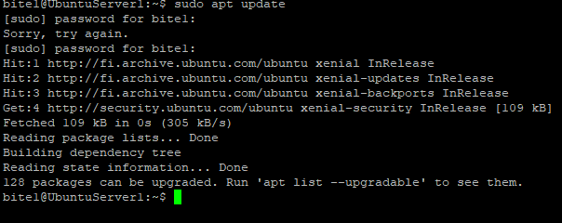

**Installed:**

**sudo apt install apche2 -y**

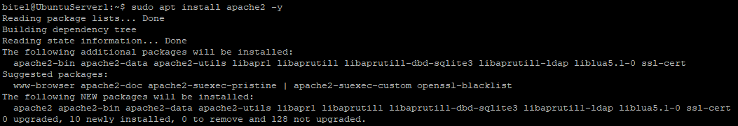

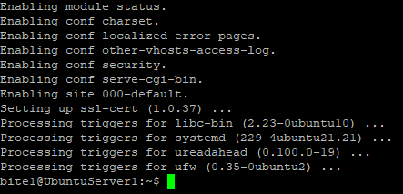

**Checking services:**

**sudo systemctl start apache2.service**

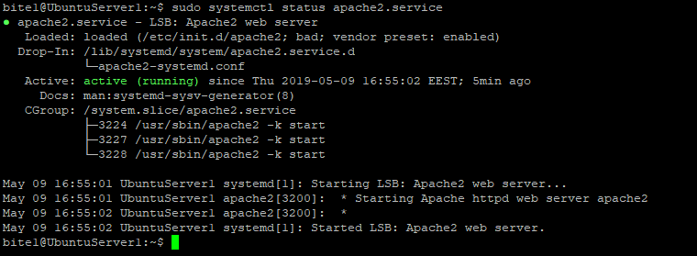

**Checking on Xubuntu worked successfully**:

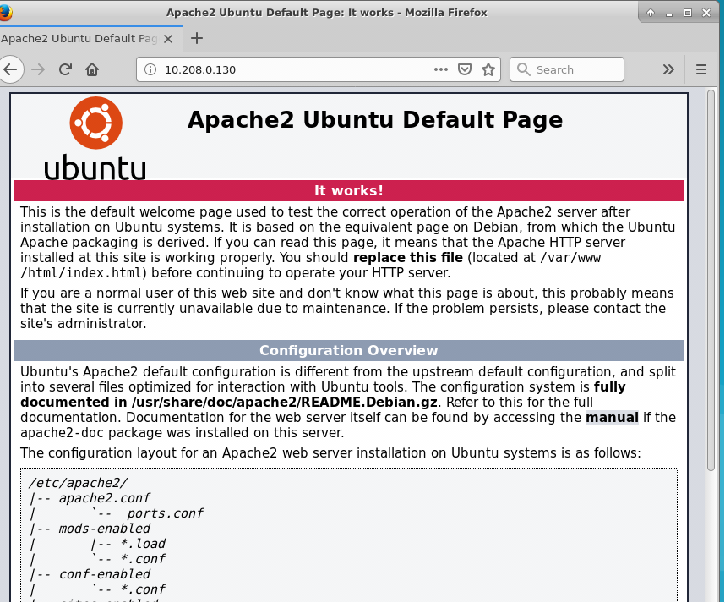

**Installing MySQL Server**

**sudo apt install mysql-server**

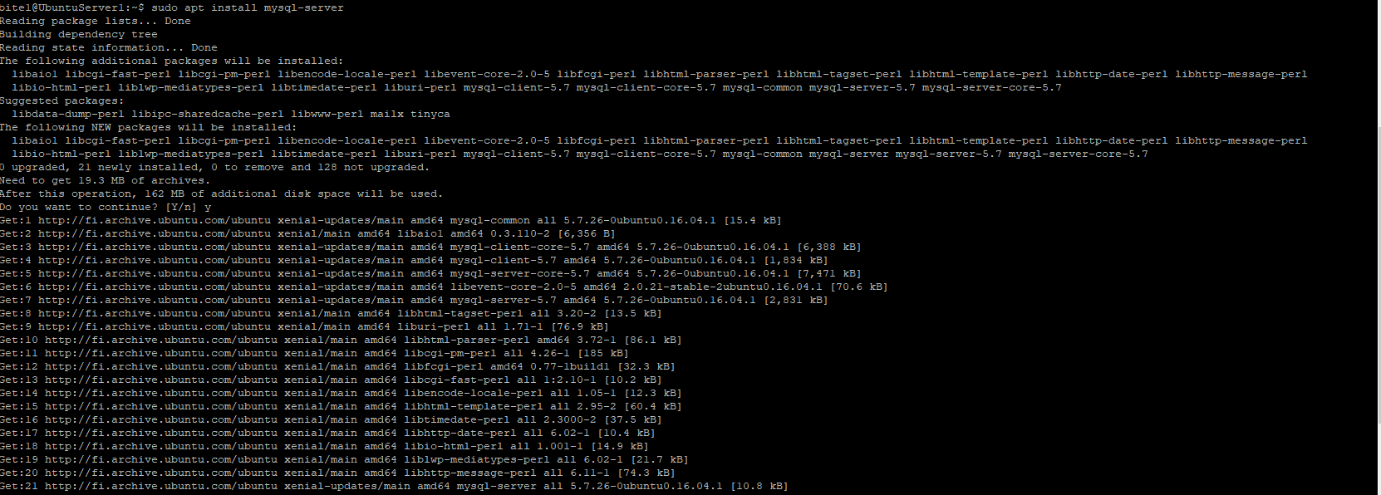

**sudo systemctl status mysql.service**

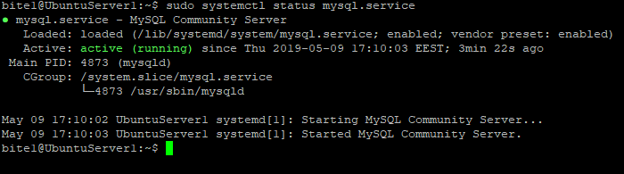

**Installation of PHP**

**Install:**

**sudo apt install php**

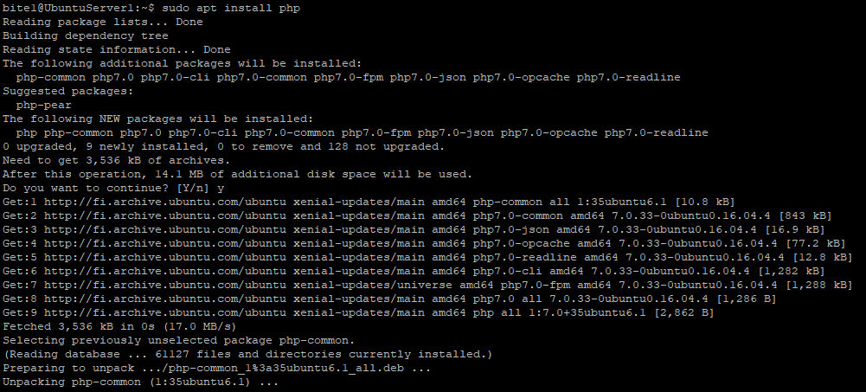

Verification of installation: php -v

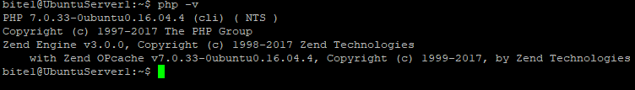

Testing PHP: Tested on Xubuntu

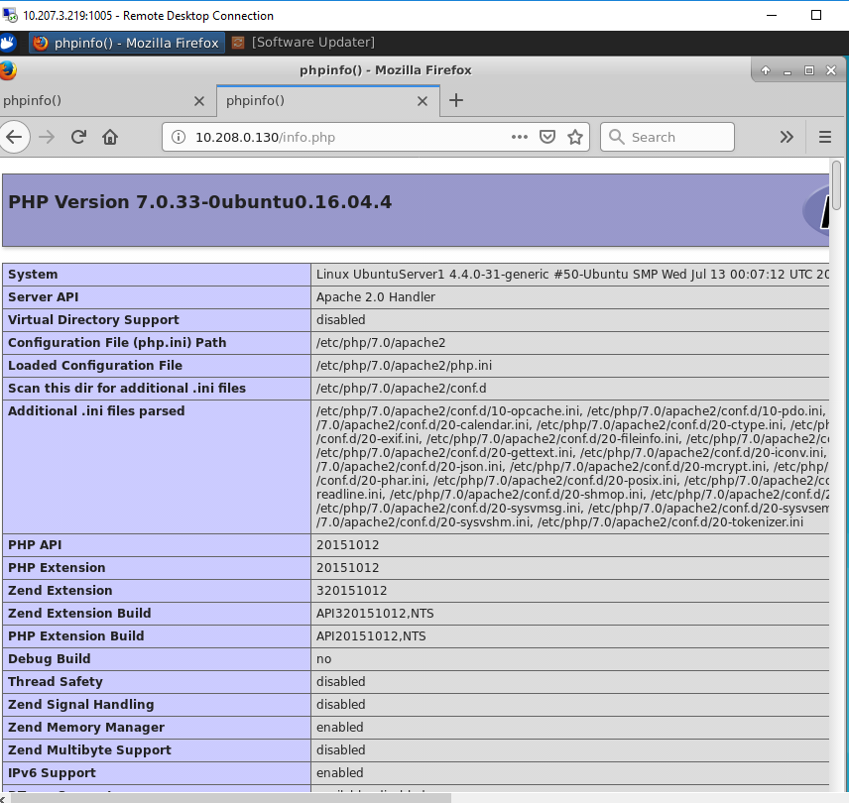

**Manage MySQL Database**

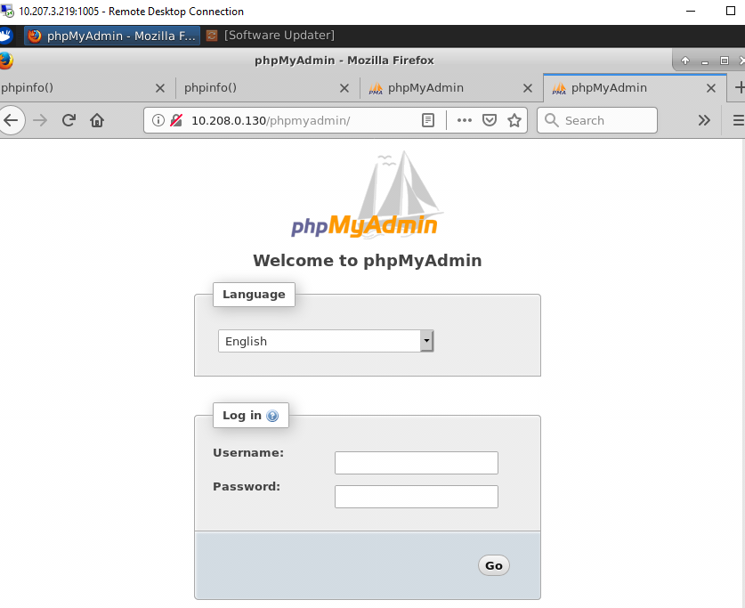

**After login:**

